Level 27 -> Level 28

The goal of this level is to access **a git repository at ssh://bandit27-git@localhost/home/bandit27-git/repo.** The password for the user bandit27-git is the same as for the user bandit27. We need to clone the repository at our local computer and find the password for the next level.

**Steps to follow:**

1. We need to create a directory were we will clone the git reposiory using mkdir.
2. Clone the repository using simple command **git clone followed by the location of the repository i.e. ssh://bandit27-git@localhost/home/bandit27-git/repo.**
3. Use the password of bandit27 as mentioned in the level goal.
4. **README file** is present in the **repo** repository.
5. **Cat** the README file and get the password.

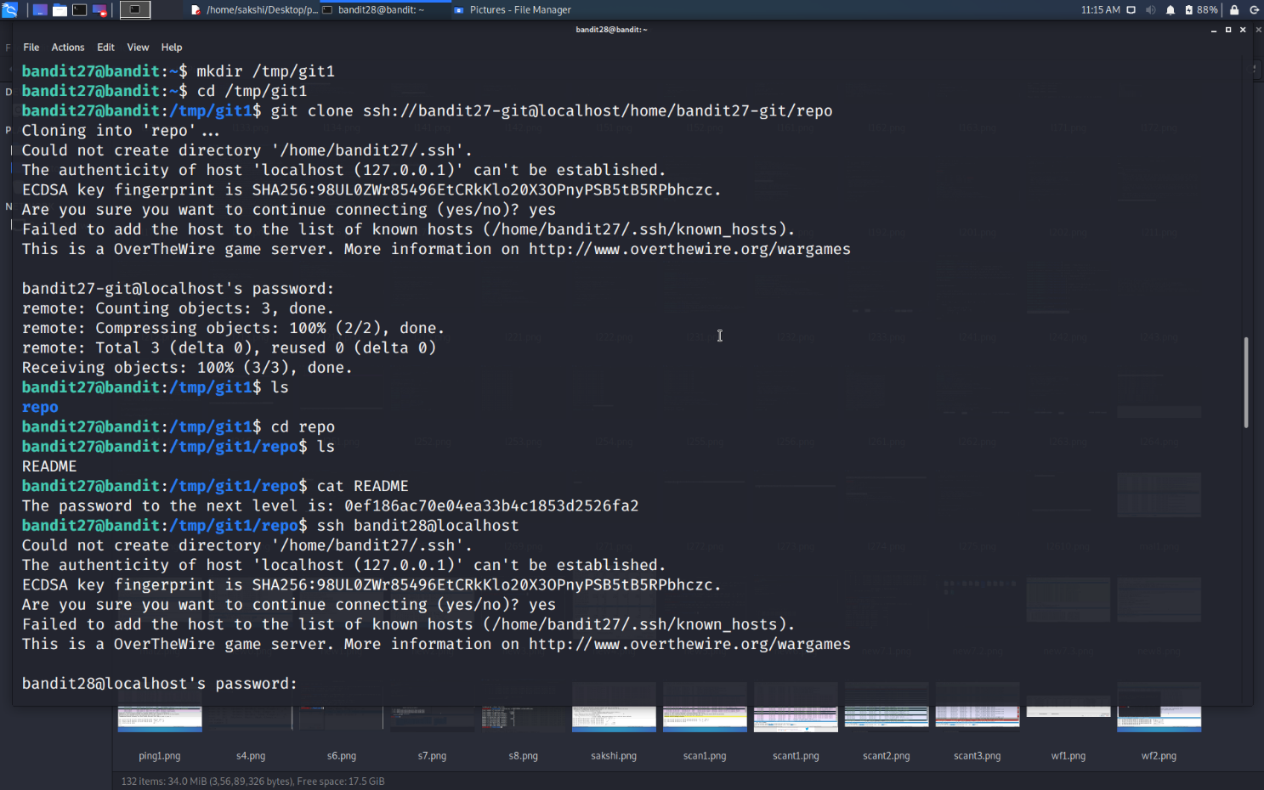

Use the command **ssh bandit28@localhost** to connect to the level 28.

Enter the password and hit enter.

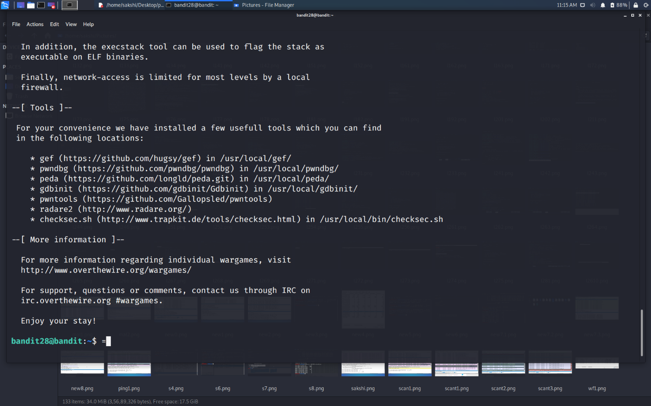

Successfully passed level 28.…